Paper Title Starts Here: Please Center
use Helvetica (Arial) 14
[0ne line space]
FULL First Author^{1, a}, FULL Second Author^{2,b} and Full Third Author^{3,c}
¹Full address of first author, including country
²Full address of second author, including country
³Full address of third author, including country
ªemail, ^{b}email, ^{c}email
[Two line spaces between e-mail and abstract lines]
[the rest of the paper, please use Times Roman (Times New Roman) 12]
Abstract - This template explains how to prepare your camera-ready paper for Publications. It is advisable to read these instructions and follow the outline of this text. Please make the page settings of your word processor to A4 format (21 x 29,7 cm or 8 x 11 inches); with the margins: bottom 1.5 cm (0.59 in) and top 2.5 cm (0.98 in), right/left margins must be 2 cm (0.78 in).
[One line space]
Keywords: List the keywords covered in your paper. These keywords will also be used by the publisher to produce a keyword index.
[Two line spaces]

1. Introduction
[One line space]
Manuscripts must be in English. It is assumed that when you submit your paper you are automatically transferring the copyright of the paper to us for publication in the proceedings. Should authors use tables or figures from other publications, they must have obtained the copyright for reproducing them. Do NOT use page numbers in your manuscripts.
Use italic font for emphasizing a word or phrase. Do not use boldface typing or capital letters, except for section headings.
[One line space]
2. Section Headings
[One line space]
2.1 Subsection Headings.
[One line space]
Use boldface capital and lowercase letters for the section headings and/or subsection headings.

Tables/Figures should be referred with Table/Figure 1, Table/Figure 2 ... and so on. Each table/figure should have a title. For example,
[One line space]
Table 1. Proportion of concrete mix
w/c ratio | Water  (kg/m³) | Cement  (kg/m³) | Fine aggregate  (kg/m³) | Coarse aggregate  (kg/m³)
0.53 | 220 | 412.5 | 641.2 | 1046.1

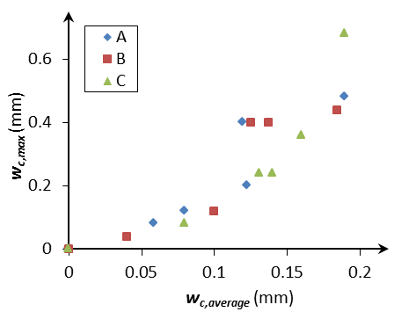
Figure 1. The relationship between the average and maximum crack widths.
[Two line spaces]

Note that figures will be published in black and white in the proceedings. Therefore adequate colors should be chosen when you prepare your manuscript.

Equations should be numbered in order in terms of paper not in terms of individual sections. They should be indented by 5 mm (0.2"). For example,
[One line space]
c² = a² + b². (1)
[One line space]
References should be cited in the text using square brackets such as [1], [1,2], [1-5,7]. References should be numbered based on the order of their appearance in the paper.
[One line space]
Acknowledgements – This work was supported by The Royal Society through an international joint project (JP0807232) and The National Natural Science Foundation of China through an international key project (50020105806).
[Two line spaces]

References
[One line space]
For Journal papers: Authors (initial. Surname). Paper title. Journal title, year, Vol.(issue no.)pages.
[1] A.B. Smith, J.A. Davies and D.M. Short. Diffusion of chloride in concrete. Corrosion Science, 2001, 54(4)667-688.
For books: Authors. Book title. Publisher, publisher place, published year.
[2] A.B. Smith, J.A. Davies and D.M. Short. Mechanics of Materials. Cambridge University Press, Cambridge, 1998.
For conference papers: Authors. Paper title. Conference name, place, date of conference, pages.
[3] A.B. Smith, J.A. Davies and D.M. Short. Diffusion of chloride in concrete. 3rd International Conference on Materials, London, Sept. 21-25, 2001, pp.45-67.
For papers published in a book: Authors. Paper title. In: “Book title” by “authors of the book”, Publisher, publisher place, published year, pages.
[4] A.B. Smith, J.A. Davies and D.M. Short. Diffusion of chloride in concrete. In: “Materials” by J.A. Kettle and H.Y. Wang, Cambridge University Press, Cambridge, 1998, pp.45-67.

